GENESIS CHARTER

# **Mission and Vision**

To bring together people with similar interests by providing a mutually supportive environment where one can enhance, exhibit, and extend their knowledge in their interested fields of research or work on projects together as a team.

# **Purpose of the Club**

Prospective students and active professionals should always be aware of new technology, applications, and developments in their field so they can position themselves to take advantage of emerging trends. One can learn, teach, discuss and develop a new project, perform research or work on a new finding integrating the existing knowledge together as a team

# **How the club functions**

Enthusiasts who avail themselves to be a part of the club can work in specified fields of interest (App development, Web development, Internet of Things, 3d - Modelling, Machine Learning, Deep Learning, VFX, Animation, Programming, Architecture, Robotics, Embedded Systems, Pen Testing, etc) and work on projects of their own choice or work on a project as a team.

Working as team functions as having team leaders, managers, executives, and other positions to work on. Members are likely to participate in hackathons, competitions and science fairs organized by various committees or organizations outside the campuses from both regional and national levels on various platforms (hack-the-box challenges, Capture the flag for pen-testers and ethical hackers, A 'Design & Award for web developers, hash code, code jam by google for programmers and problem solvers, NIYANTHRA for graphical designers, etc ). so, that one can understand the competitions of the outside world and can gain experience how to approach a certain task and extended knowledge with the group.

The members of the club will be indulging in theory reading and discussion of papers and interesting articles (Machine Learning, Deep Learning, Neural Networks, Optimization algorithms, Number theory, Quantum Computing, etc). We respect each other’s ideologies and learn from each other.

## Fields of Interest: For Technology -

## WEB DEVELOPMENT

1. ANDROID DEVELOPMENT
2. PEN – TESTING
3. 3D - ANIMATORS
4. IOT
5. ANIMATION & VFX
6. PROGRAMMERS

## For theory reading, paper and article discussion:

1. Machine Learning
2. Neural Networks
3. Deep Learning
4. Algorithm optimization…

# **Structure (Hierarchy)**

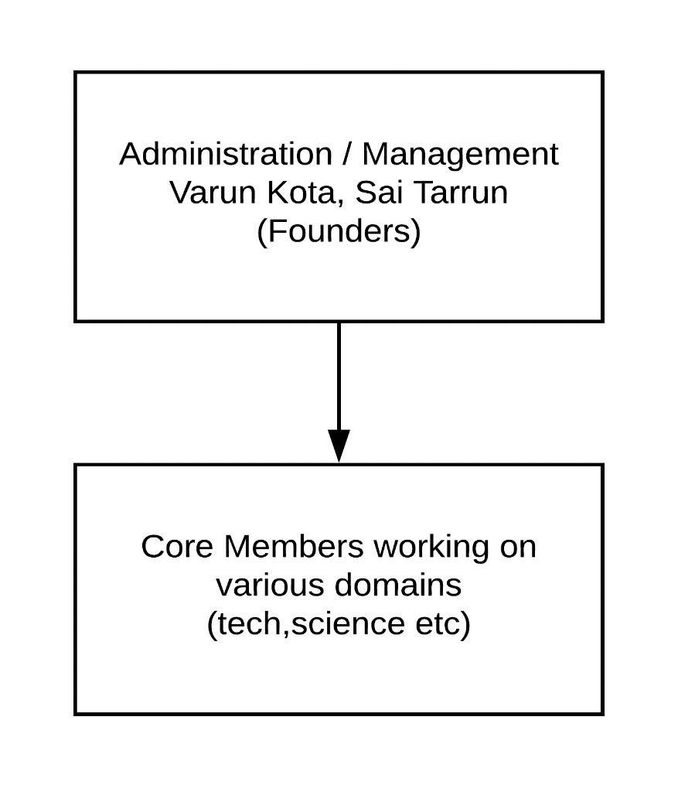

## **The functioning of core members:**

We ensure that proper and smooth functioning of the club takes place and all members get proper roles and are directed in a proper direction to work in their respective fields (EITHER RESEARCH OR PROJECTS, COMPETITIONS)

## **Recruitment process & criteria of selection (Tentative)**

Students have to undergo a basic test

1. Situation test: To see their approach towards solving a problem
2. Group discussion into their fields of interest and equip themselves to compete with the outside world.